Patient Information Sheet
Transperineal Template Prostate Mapping Biopsy

What is the prostate?

The prostate is a gland found only in men that sits just below the bladder. When you pass urine it flows through a tube (urethra) and out through the penis. The urethra has to pass through the prostate before reaching the penis. Fluid produced by the prostate forms part of the semen and may help to nourish sperm.

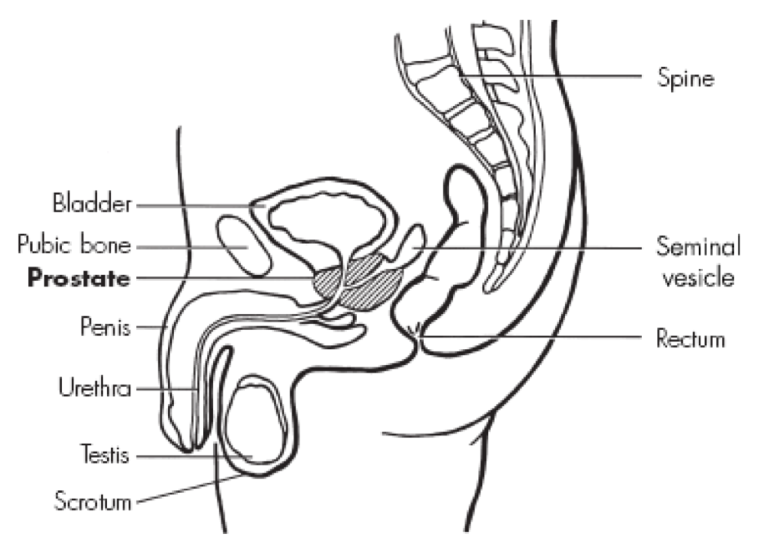

Traditional Transrectal Ultrasound Scan and Biopsy

Standard practice is to have a trans-rectal ultrasound (TRUS) and biopsy if you have either a raised PSA or the prostate gland fees abnormal on digital examination using a gloved finger. An ultrasound scanning probe is inserted into the rectum (back passage) and a local anaesthetic is given via a needle also through the back passage, around the prostate gland.
A biopsy needle is inserted through the lining of the back passage and between 6 and 14 samples of tissue are taken. As ultrasound is not very good detecting the specific location of prostate cancer, the ultrasound is used to identify the apex, mid, and base of both the left and right lobes of the prostate, so that random biopsies can be taken from these areas.
As well as being randomly placed, TRUS and TRUS biopsy can give no detailed information as to whether the cancer (if found) has spread beyond the confines of the prostate gland.

Why should I have a Transperineal Template Prostate Mapping Biopsy?

There are a number of reasons why MRI and prostate mapping biopsies may be suitable for you:

Precision Diagnosis

If you have a raised PSA, need to have a prostate biopsy, and wish to have the most accurate diagnosis of whether you have prostate cancer and if you do, the extent and aggressiveness of the disease. OVER 20% OF PATIENTS REQUIRE A SECOND BIOPSY WITH STANDARD TRUS BIOPSY. Prostate Mapping biopsies get accuracy and precision in one biopsy.

If you have a raised PSA and although one or more prostate biopsies have not detected any cancer so far, there is chance that you may still have prostate cancer that has been missed.

If you have a raised PSA and need to have a prostate biopsy, but do not wish to have their biopsy under local anaesthetic.

If you have been told that you have a low grade and non-aggressive cancer and you want to be sure that this is an accurate diagnosis before considering “active surveillance”.

If you want to have a precise location for your cancer to help you decide if you would like one of the newer minimally invasive treatments

Precision Risk Stratification

Prostate Mapping is the most accurate way to risk stratify you without removing the prostate itself. This will put you in the best position to make informed choices about your treatment and may also make it possible to have one of the newer, less invasive methods of treatment which specifically target the cancer within your prostate.

Transperineal Template Prostate Mapping Biopsy

A transperineal template prostate mapping biopsy is carried out under general anaesthetic. This is normally a daycase procedure but some patients may need to stay for 1 night.
5 days before the biopsy you will need to start a tablet called Tamsulosin to minimise the risk of retention of urine (You will need to continue this for 2 weeks post procedure as well). You will be seen by the surgeon prior to the procedure. He will answer any questions you may have. You will be asked to sign a consent form to state that you agree to have the procedure if you have not already done so. You will be assessed by a Consultant Anaesthetist who will discuss the anaesthesia.
Once you are under the anaesthetic a plastic tube called a catheter is inserted through the penis into the bladder so that the water passage can be seen properly throughout the procedure and avoided. After the biopsies have been taken, the catheter is removed.
The procedure lasts for 30 to 45 minutes and involves taking 20-50 biopsies through the skin that lies in front of your back passage rather than through the back passage. An oral antibiotic is given 1 hour before the procedure and an intravenous antibiotic is given at the start of the procedure. A thick padding will be placed over the area of skin that the needle has gone through to prevent a lot of bruising. This padding should be left for at least 6 hours.

How are prostate mapping biopsies carried out?

An ultrasound probe is inserted into the back passage and the prostate is scanned. A grid with holes placed every 5mm, is placed on the perineum, a biopsy needle is inserted through each hole and the prostate is sampled every 5mm. Each section biopsied is placed in a separate pot for a Consultant Histopathologist to examine under the microscope. A report is given for each area (between 6 and 20 different areas) telling us whether each biopsy has cancer in it or not. Other information is also given such as whether the tissue looked inflamed or whether there are other features such as precancerous areas in the prostate.

What are the potential side effects of prostate mapping biopsies?

Transperineal biopsies carry no extra risk than a normal prostate biopsy carried out through the rectum, and with regards to infection and sepsis the risks are lower. Complications include:
- bruising of skin in all men and occasionally bruising that spreads to the scrotum
- prostatitis (inflammation or infection of the prostate) in some men
- temporary discomfort or pain in the back passage area (most men)
- bloody urine for the first few hours to a maximum of 2 days in most men
- bloody semen in most men lasting for up to 3 months in a few men
- retention of urine requiring a temporary catheter (2-10 in 100)
- infection (requiring admission and intravenous antibiotics, 0-1 in 100)
- a few men have experienced temporary poorer erections

What happens after the procedure?
You can go home the day of the procedure once you have passed urine.
You may experience some perineal pain or discomfort after the procedure but paracetamol or other simple pain killers should be adequate. You should avoid any medication containing aspirin for 24 hours as it causes blood thinning and will therefore increase the risk of bleeding. You can expect to see some blood in your urine for 1 - 2 days following the biopsies. You may notice some blood in your semen for up to 3 months. If the bleeding becomes excessive, prolonged or if you start to pass blood clots then you should seek medical attention. In up to 10% of patients, swelling may occur in the prostate gland as an inflammatory response to the biopsies being taken. This can cause difficulty in passing urine and may stop you passing urine completely. This is known as urinary retention and you would then need a catheter inserted to drain your bladder for a few days. You will not be allowed to go home until you have passed urine. There is a <1% risk of developing sepsis (a very bad infection) following prostate biopsy. The antibiotics you will be given should help prevent this. If you develop flu-like symptoms within 24 hours of the biopsies being taken (fever, cold shivers, general aching) you should seek medical assistance immediately. You should drink plenty of fluids.
You will be given contact numbers which you can call at any time should you have a problem.

When will the results be available?

You will be seen in the clinic in approximately 7 -10 days after the procedure with your results. The reports will indicate where the cancer is, how much cancer and how aggressive it is by denoting the Gleason score of each focus and also tell you how many biopsies were positive in each location.

If you would like more information or would like to see a Manchester Urology Consultant to discuss things further please call 01614957796 to arrange an appointment.

